**Lecture1**

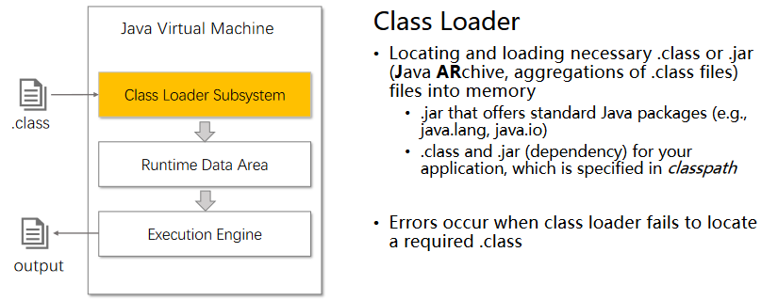

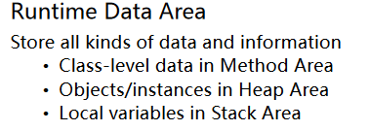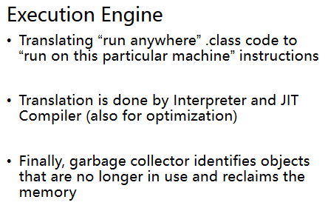

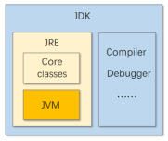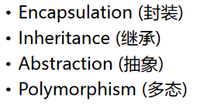

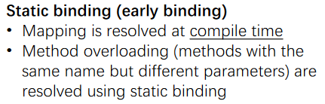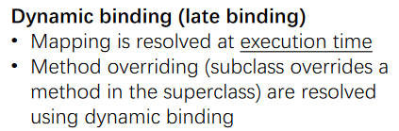

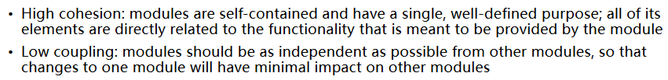

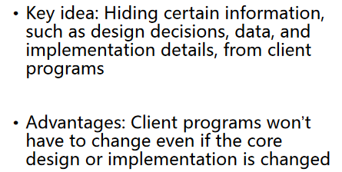

**Lecture2 Generics, Collections**

**Generics**

E non-primitive type

why? type erasure; primitive is stored in stack

Generic classes, interfaces, methods

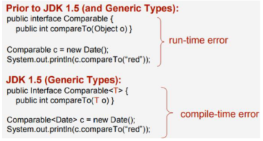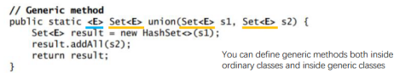

<T extends BoundingType1&type2>

T could be any subtype of 1,2

Inheritance

Number←Integer √

Pair<Number>←Pair<Integer> ×

Wildcards通配符

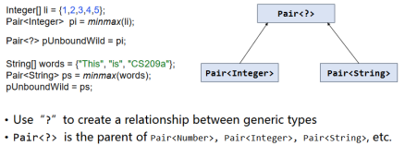

**Collections**

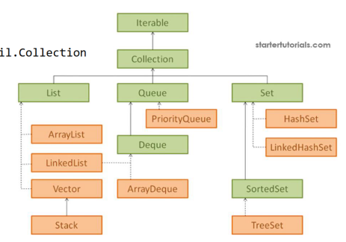

Java2 Cheating Paper

@Jiko

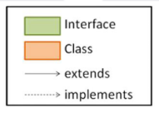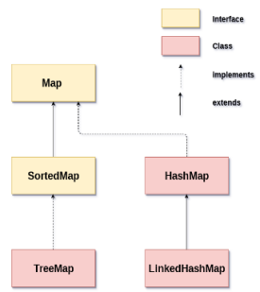

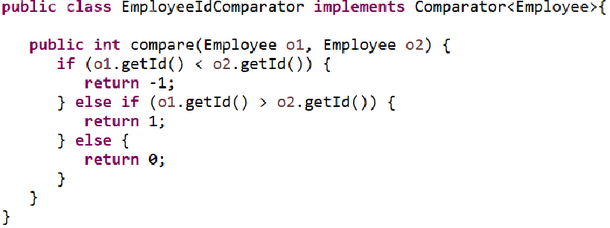

**Lecture 3 Lambda**

**Functional Programming**

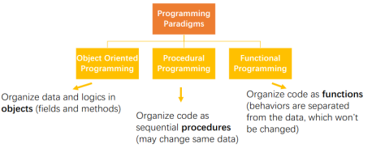

Pure function

Always produce the same output for the same input. *Copy, create rather than modify.*

No “while” or “for” loop in functional programming. *Use recursion rather than iteration.*

Pros:

Easy to debug, test, and parallelize.

Complexity is dramatically reduced

**Lambda Expression**

Syntax

(param1, param2) -> {expressions or statements, and return}

*(param1, param2) -> {return param1 > param2;}*

*(param1, param2) -> param1 > param2;*

Functional interface is an interface with a single abstract method.

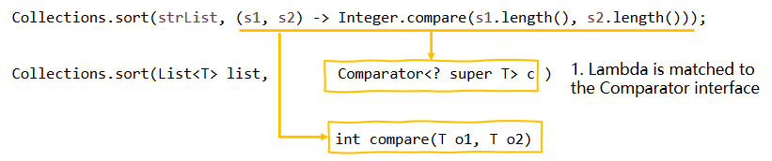

Type inference

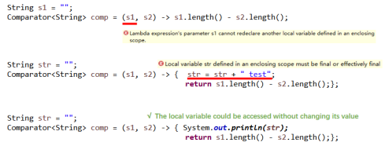

Use cases

Method references

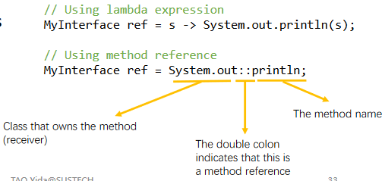

Static method”ClassName::staticMethod”

Instance method(Bound)”InstanceName::instanceMethod”

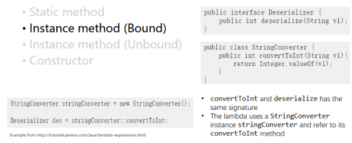

Instance method(Unbound)

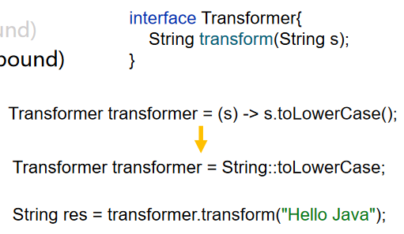

Constructor.

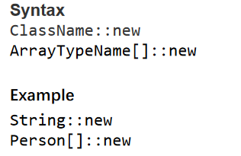

Java functional interfaces

Consumer<T> 是一个消费者接口，表示接受一个参数（类型为T），并对该参数执行某些操作，但没有返回值。

Supplier<T> 是一个供应商接口，表示提供一个值（类型为T），但不接受任何参数。

Predicate<T> 是一个谓词接口，表示对输入参数进行某种判断，返回一个布尔值。

Function<T, R> 是一个函数接口，表示接受一个参数（类型为T），并返回一个结果（类型为R）。

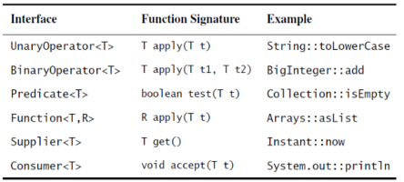

**Lecture 4 Stream**

**Java 8 Stream**

Used to process collections of objects

Data stream is obtained from a source

Data stream is processed through chained intermediate operation

Getting the result from a terminal operation

*Create*

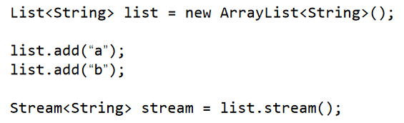

*Create2*

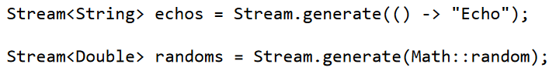

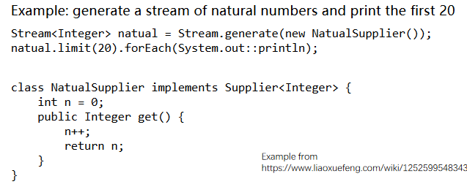

*Create3*

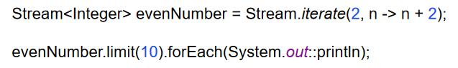

*Create4*

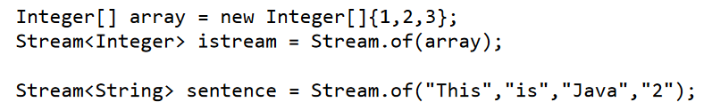

*Primitive generation*

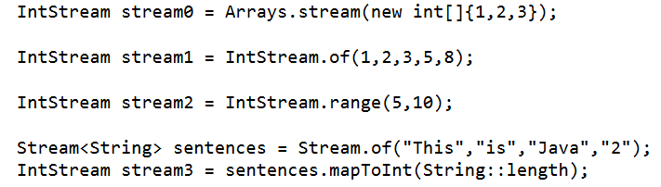

*Intermediate Operations*

[Lazy evaluation] All intermediate operations do not get executed until a terminal operation is invoked

*filter()* match

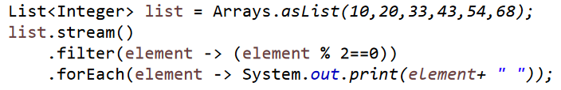

*map()*

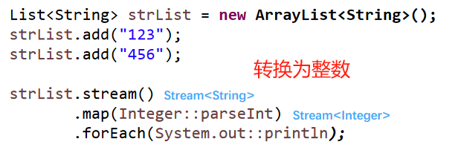

*sorted()*

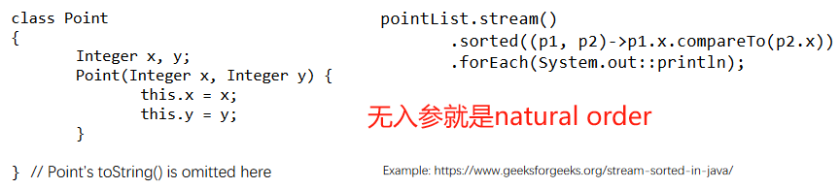

*Distinct(),peek(),limit(),skip()*

*Terminal Operations*

A terminal operation returns a non-stream

type of result. [Eager execution] Terminal operations are

early executed

*Reduction*

min(),max(),average(),sum(),reduce()

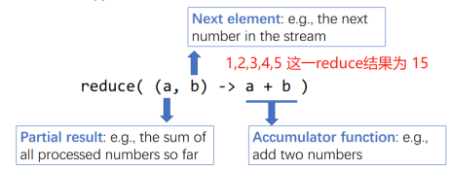

*Collecting Results*

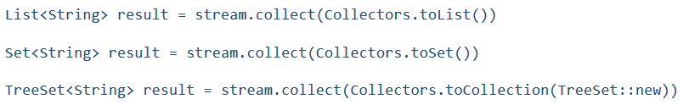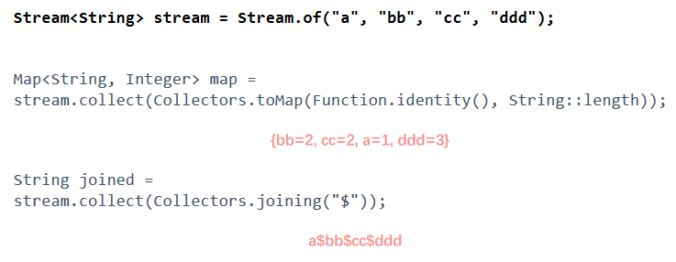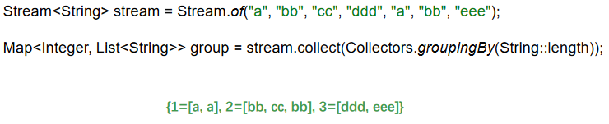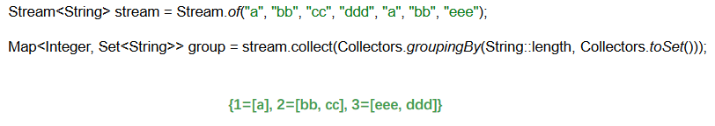

Lazy Evaluation:

延迟计算，节省资源（优化中间操作），并行处理，灵活性（可以在不同的流操作之间插入新的操作）

**Optional<T> class**

a type-level solution for representing optional values instead of null references

**Lecture 5 I/0**

**I/O**

Input Stream and Output Stream are Byte Stream, Reader and Writer are Character stream

**i18n & Character Encoding**

*ASCII*

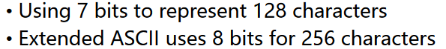

*GB*

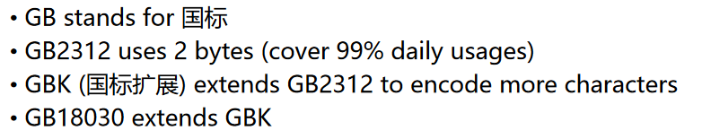

*Unicode*

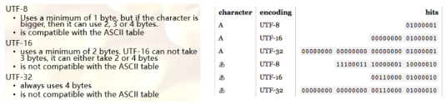

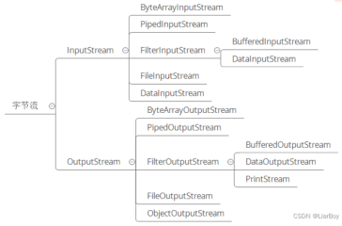

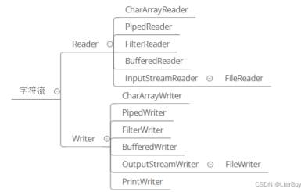

**Byte Streams & Character Streams**

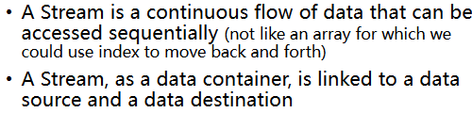

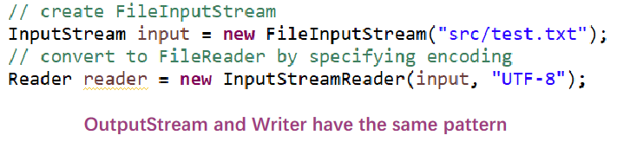

**Combining Stream Filters**

**Reading/Writing Text Input/Output**

**I/O from Command Line**

**Lecture 6 Exception**

**Persistence and Serialization**

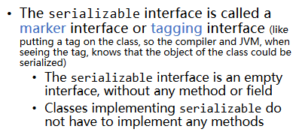

ObjectOutputStream.writeObject(myObject)

ObjectInputStream.readObject()

**Working with Files**

Path

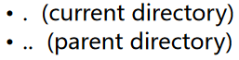



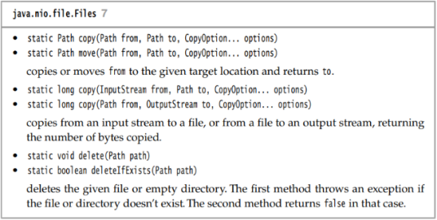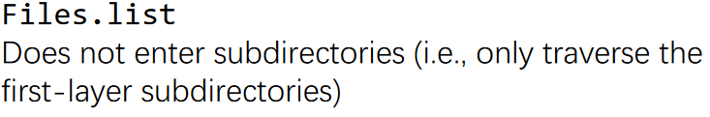



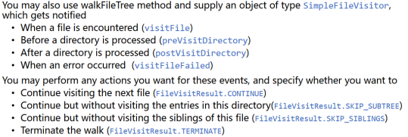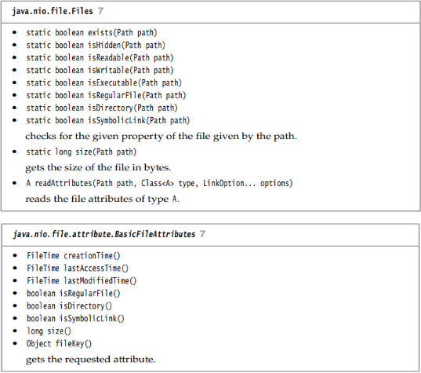

**Exception Handling**





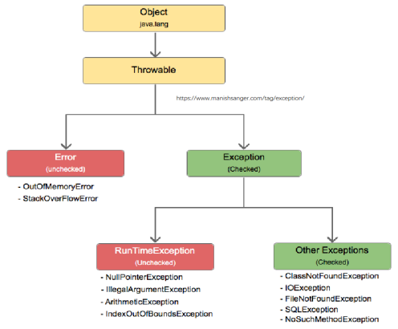

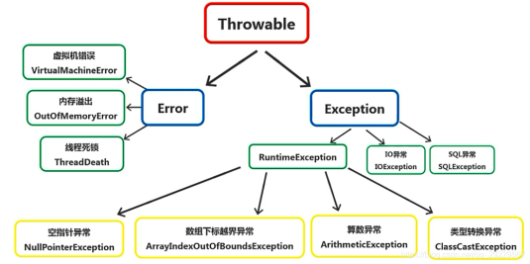

**Lecture 7 Concurrency**

**Overview**

Processes进程，Threads线程 一个进程有多个线程

**Creating & Starting Threads**

Extends Thread class or Implement Runnable interface(better)

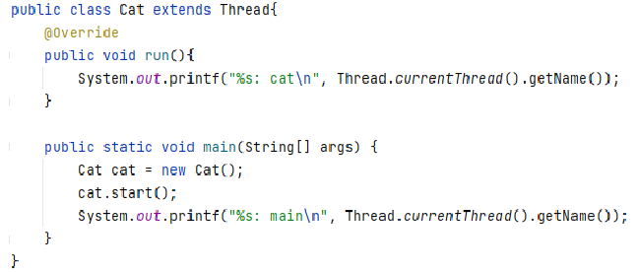

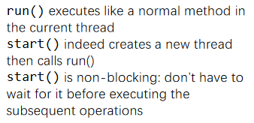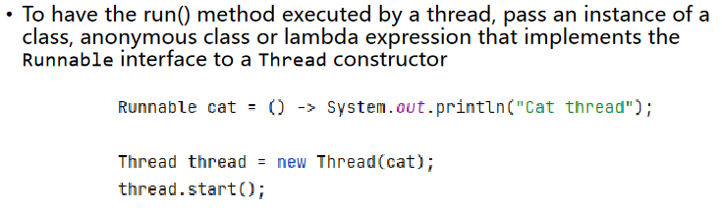

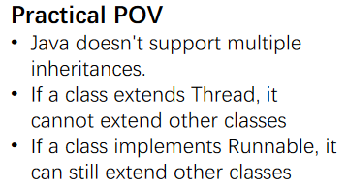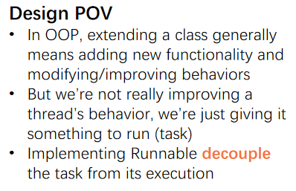

**Synchronization**

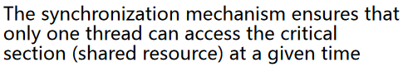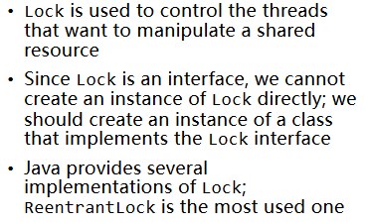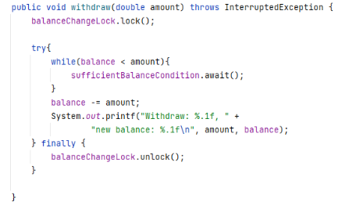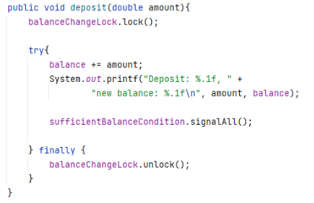

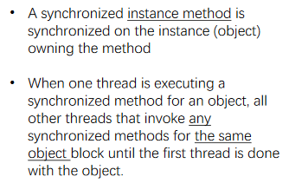

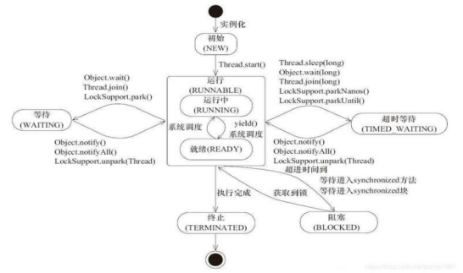

Volatile

Visibility: 每次访问该变量时都会强制刷新缓存

Ordering: 禁止指令重排序，确保有序性

不保证原子性，如i++

**Thread-safe Collections**

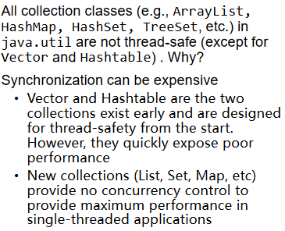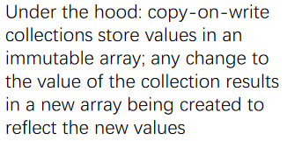

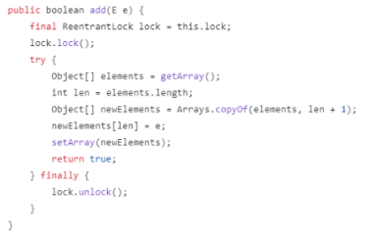

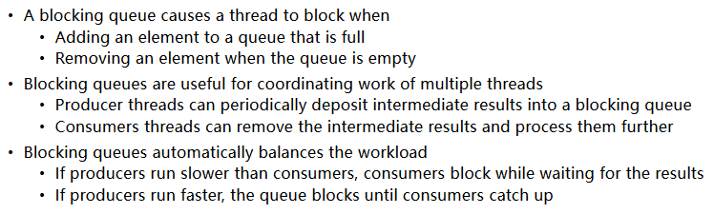

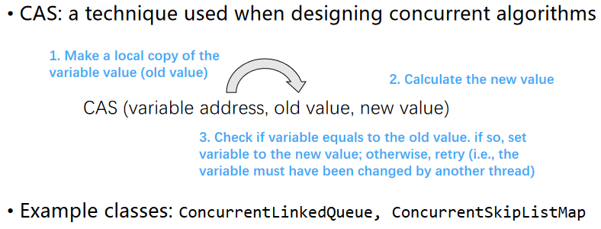

**Tasks and Thread Pools**

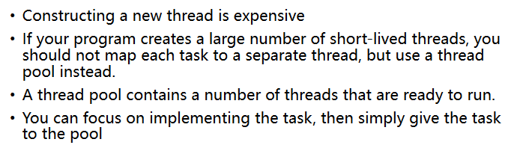

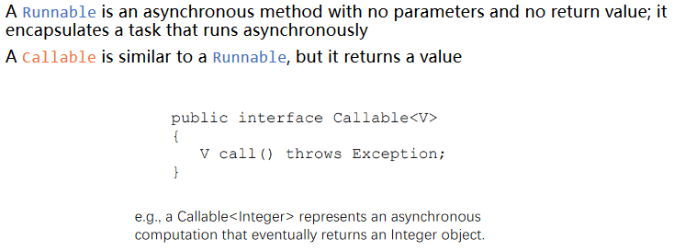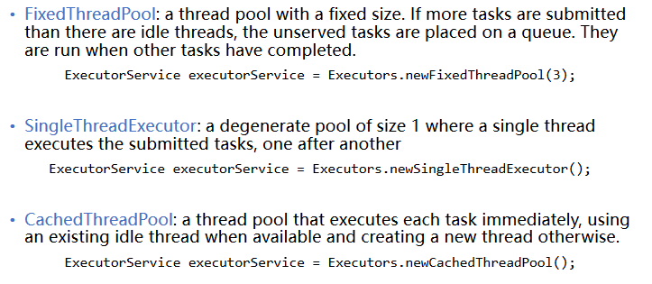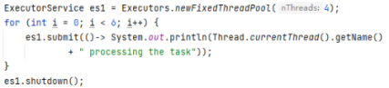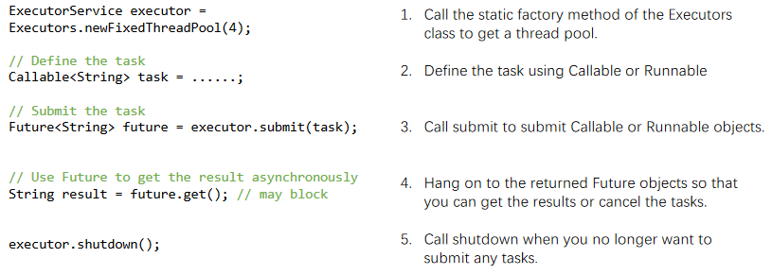

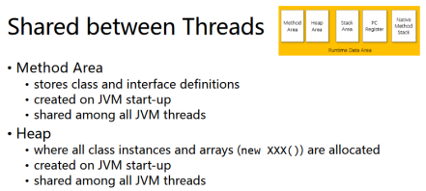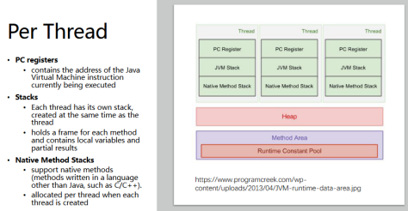

**Lecture 8 Socket**

**Socket Programming**

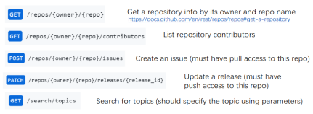

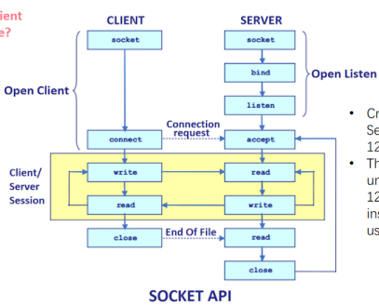

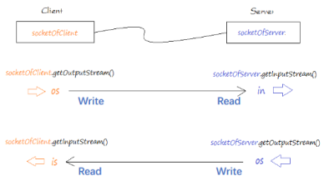

**Getting Web Data**

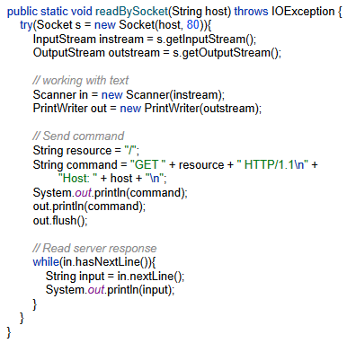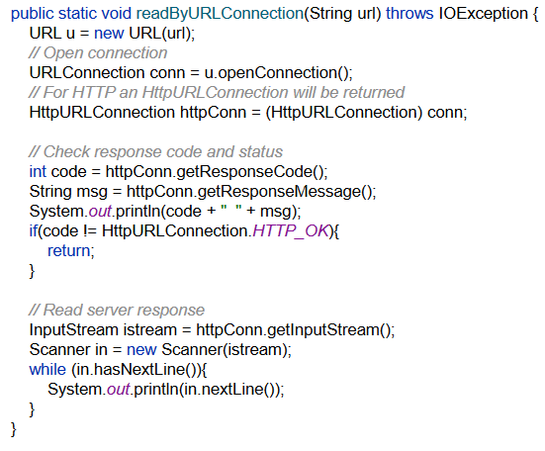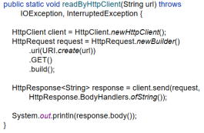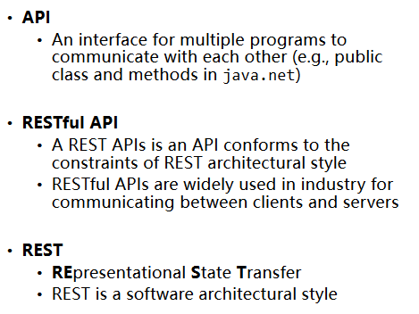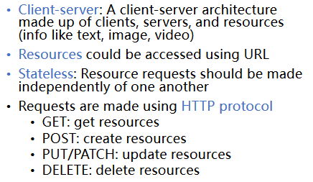

**Lecture 9 JavaFX GUI**

**Swing**

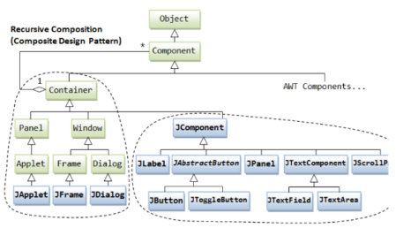

**JavaFX**

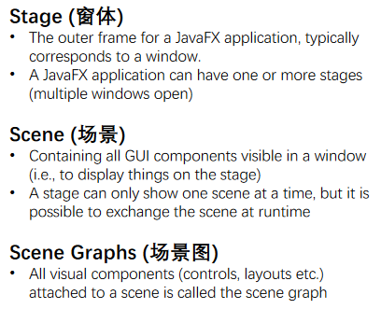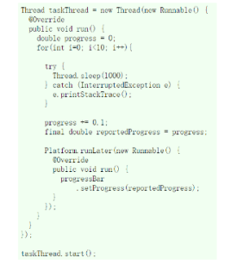

**Lecture 10 Reflection**

**Reflection**

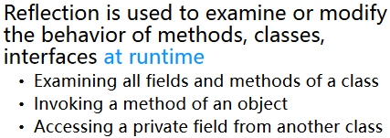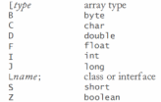

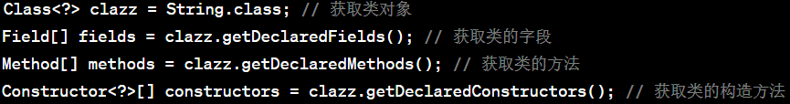

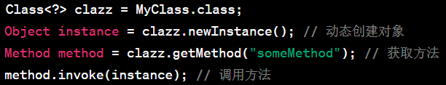

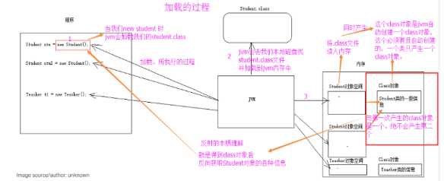

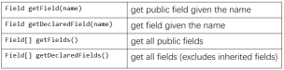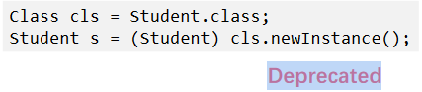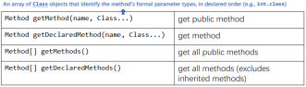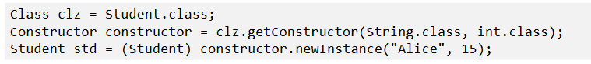

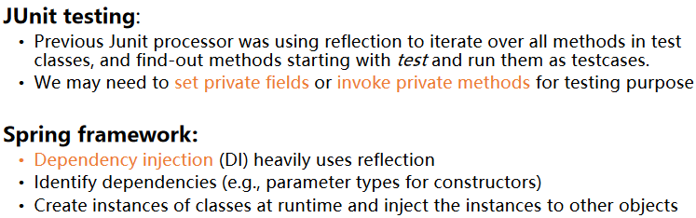

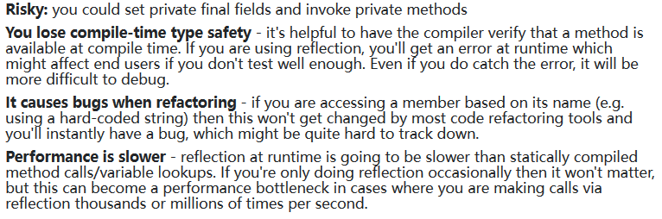

**Annotation**

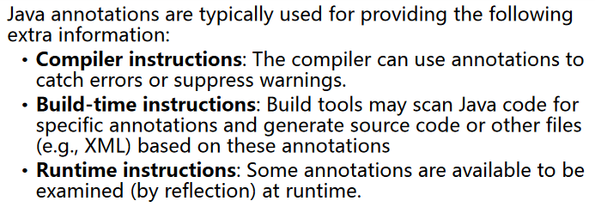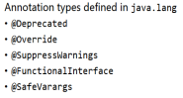

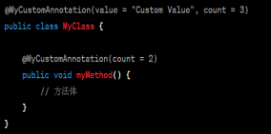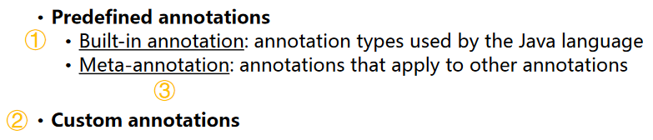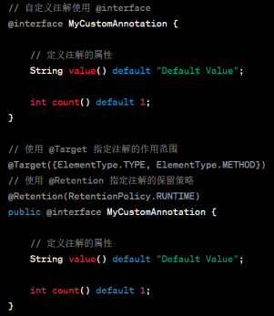

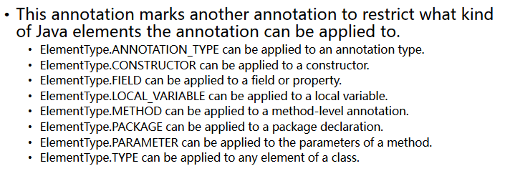

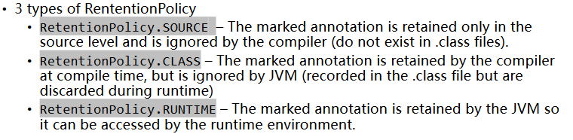

**Lecture 11 Java EE**

**Java EE**

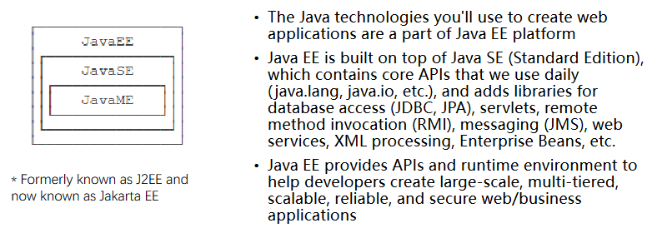

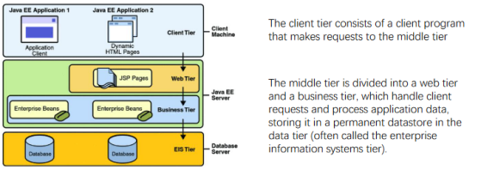

**Servlet & Containers**

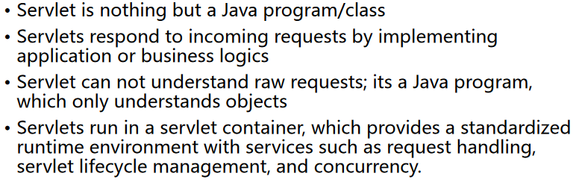

**JDBC & JPA**

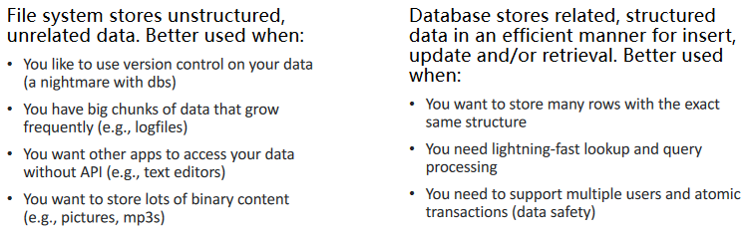

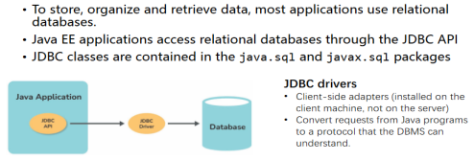

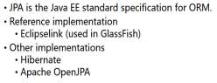

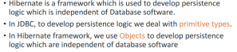

**Lecture 12 Spring**

**Spring Framework**

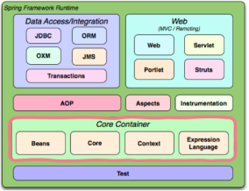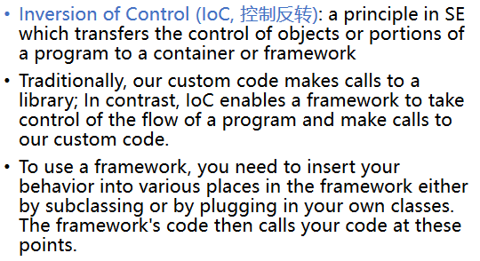

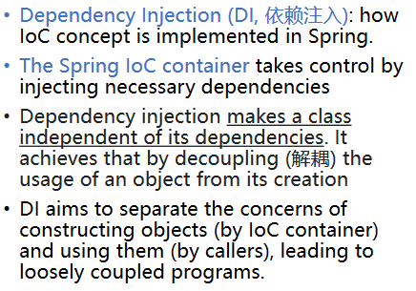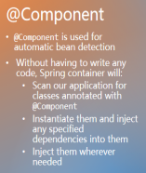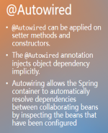

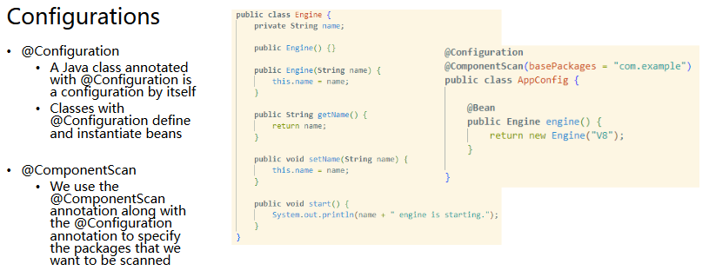

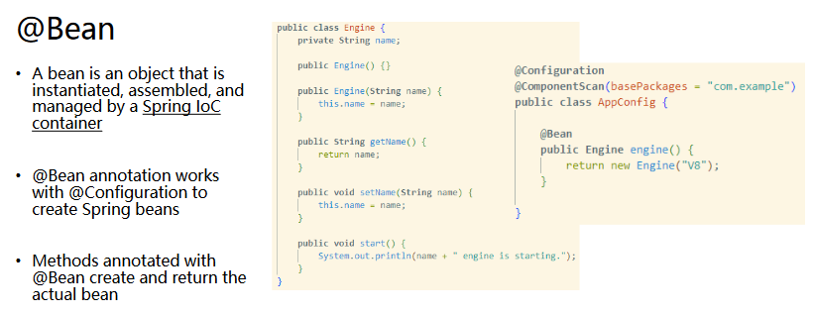

**Spring Boot**

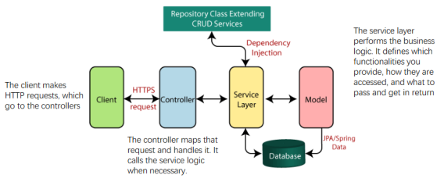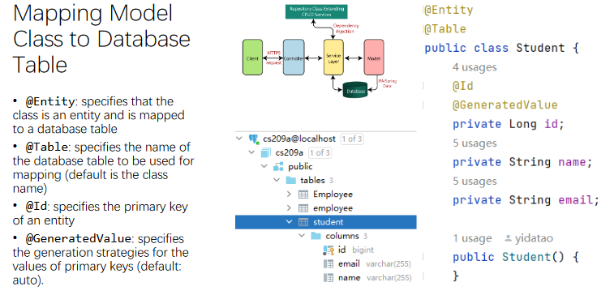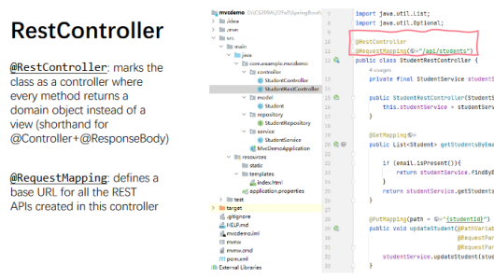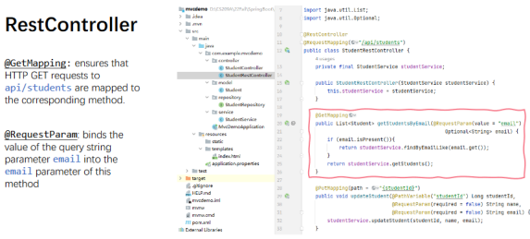

**Lecture 13**

**Logging**

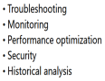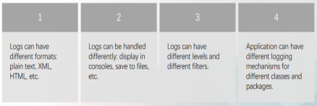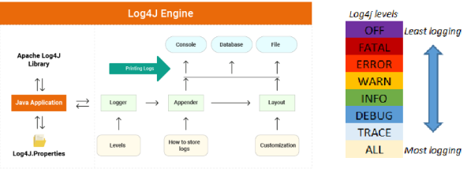

**Testing**

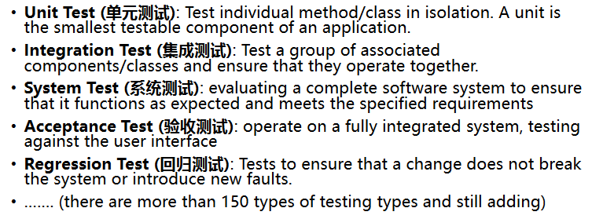



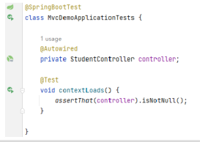

**Lecture 14 JVM**

**.class structure**

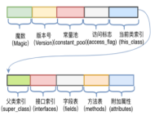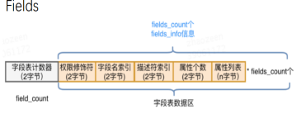

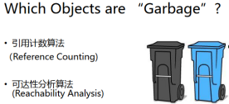

**JVM**

